  - Worksheet – Children

World Otter Day 2020
By Madison Wildlife
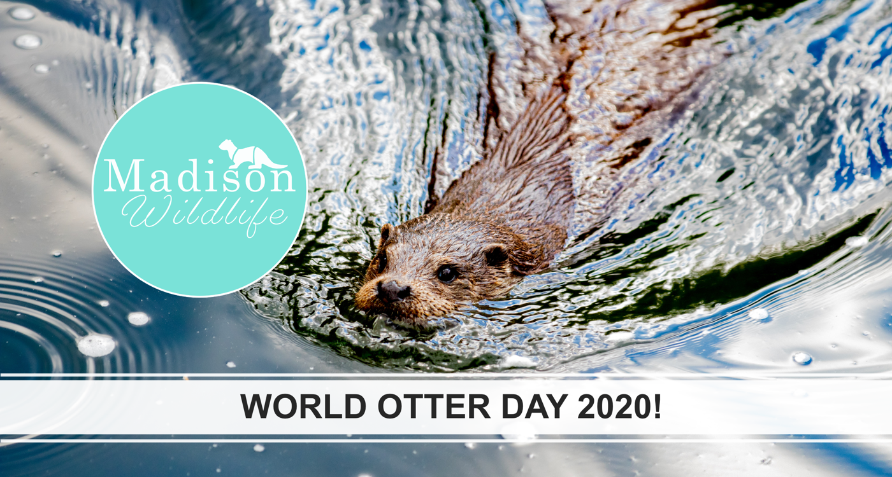

QUIZ ROUND
- How many otters are there?
………………………………………………………………………………………………….
- Which is the smallest of all otters?
………………………………………………………………………………………………….
- How many layers of fur do otters have?
………………………………………………………………………………………………….
- How do otters communicate without using their voice?
………………………………………………………………………………………………….
- How many hairs does a sea otter have per cm²?
………………………………………………………………………………………………….
- What is one threat that otters face?
………………………………………………………………………………………………….
- How can we help otters?
………………………………………………………………………………………………….

PICTURE ROUND
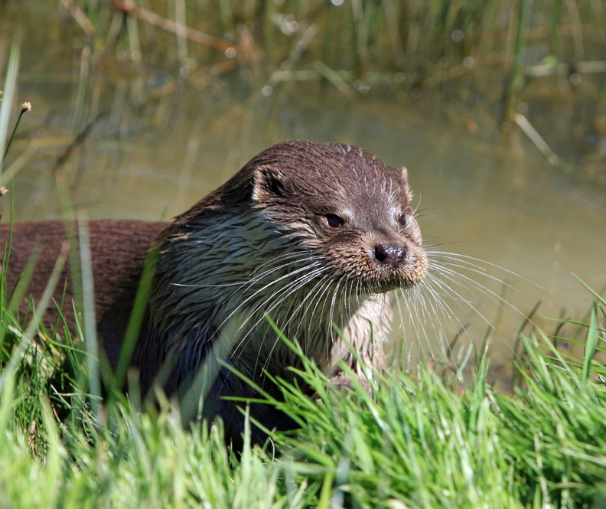
Guess the species!
Which otter is this?
…………………………………………

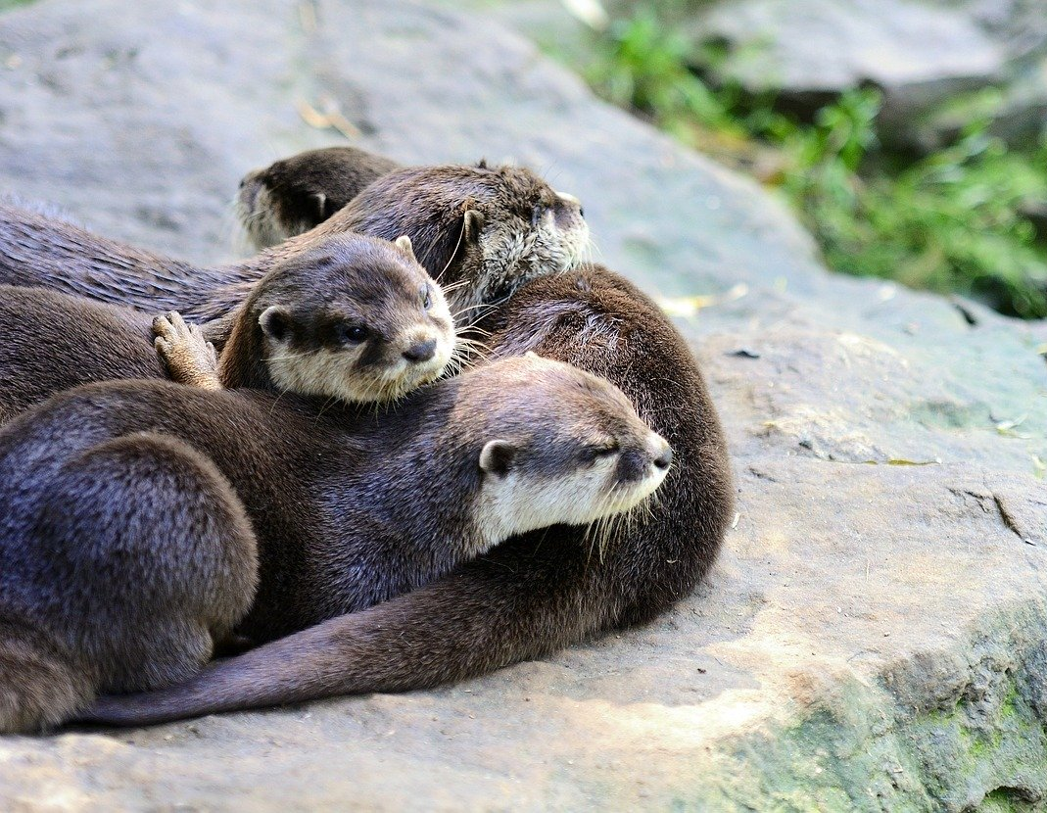
Which otter is this?
…………………………………………

Can you draw an otter?
Use this space below to draw an otter and write underneath why otters are important.

